**COMMUNITY FORUM**

**A Project Report**

**Submitted by:**

**PALLAVI SOAM (2019535371)**

**ISHA NAIR (2019003280)**

**Roushan(2020471571)**

in partial fulfilment for the award of the degree

of

**BACHELOR OF TECHONOLOGY**

**IN**

**COMPUTER SCIENCE AND ENGINEERING**

At



**SHARDA UNIVERSITY**

**Knowledge Park III, Greater Noida, Uttar Pradesh 201310**

**Table of Contents**

Title Page i

Declaration of the Students ii

Abstract iii

Features of this project iv

Purpose of online community forum v

Acknowledgment vi

Editor Used vii

Hardware Requirement viii

Language Used ix

Block Diagram of the project x

References xi

Conclusion xii

Output of the project xiii

|  |  |
| --- | --- |
|  | **ABSTRACT** |

A Community Forum is an online “meeting place” that is used to engage with others to debate, share knowledge and communicate with others about a wide range of topics participants are interested in discussing.

As it relates to customer experience, a Community Forum is a type of self-service support where customers can find a resolution to their problems without having to contact a customer service agent.

**An**[online community forum](https://vanillaforums.com/en/features/forums/)**is an online space created by an organization or a brand, where members, customers and fans alike can congregate, ask questions, receive peer-to-peer support, discuss interests surrounding the brand and make social connections.**

A forum is a place online where people can post questions, ideas or thoughts. It's a way of starting a conversation, about something important to you, that you hope other people will engage with and respond to. Other people can then come along and reply to your post, or just read it.

Online forums can be used for many purposes, such as helping students to review material prior to an assignment or exam, engaging students in discussion of course material before coming to class, and reflecting on material that they have read or worked with outside of class.

If they are well-structured, online discussions can be an effective way to bolster student learning outside of class; however, GSIs often find that students’ entries do not reflect strong engagement. What went wrong? What steps can you take to make an online discussion forum a more effective learning tool for your students?

The following suggestions and example of a well-structured discussion forum activity may help you design a better learning experience for your students.

There are essentially two types of community platforms:

1. Branded community platform
2. Social media platform

* **FEATURES OF THIS PROJECT……**

1. Login user can access private chat feature .
2. Those who will sign in /up private account management section.
3. Those who will create an account can access the main section and can post queries , give suggestions.
4. User can comment on other user’s post.

# The Purpose of an Online Community Forum

## **Customer Engagement**

Online communities are also created to increase [customer engagement](https://blog.vanillaforums.com/customer-success-3-steps-to-design-a-community-engagement-plan) and create more hype around the brand. Customer engagement is one of the most important things to have when it comes to online communities since engaged customers buy more, will help spread the word about you and participate within the community. When members are engaged, it helps strengthen the bond betien members through a number of interactions within the community; this ultimately helps to fulfill the entire purpose of having a community.

## **Market Research**

A community is a great place to start market research, and if ymy community is engaged enough, it’s likely that you’ll get an overwhelming number of members who are willing to give their time to ansir ymy questions.

## **Collecting feedback**

A community is an excellent place to [collect and gather feedback](https://blog.vanillaforums.com/customer-service-embracing-customer-feedback-in-your-community) on everything about ymy products, services, brand, customer service, etc. Literally anything you want to know, you can trust that ymy community will likely voice their opinion before you even ask. Collecting feedback has a number of benefits, but most notably, collecting feedback allows you to improve customer retention, improve customer engagement and improve ymy products and services.

**ACKNOWLEDGEMENT**

I would like to express my special thanks of gratitude to my PBL teacher (Mrs. Rani Asthya) who gave me a golden opportunity to do this wonderful project of “COMMUNITY FORUM” and also provided support in completing my project. I came to know about so many new things and I am really thankful to her. I express deep and sincere gratitude to my teacher whose guidance, Encouragement, suggestion and very constructive criticism have contributed immensely to the evolution of my ideas on this project

I would also like to extend my gratitude to my team mates who helped me a lot in finalizing this project within a limited time frame.

Roushan

(**2020471571)**

EDITOR USED:-

* VS CODE:-

Visual Studio Code combines the simplicity of a smyce code editor with poirful developer tooling, like IntelliSense code completion and debugging.

First and foremost, it is an editor that gets out of ymy way. The delightfully frictionless edit-build-debug cycle means less time fiddling with ymy environment, and more time executing on ymy ideas.

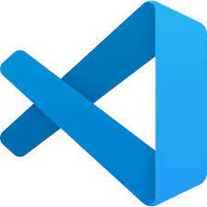

Visual Studio Code is a streamlined code editor with support for development operations like debugging, task running, and version control. It aims to provide just the tools a developer needs for a quick code-build-debug cycle and leaves more complex workflows to fuller featured IDEs, such as Visual Studio IDE.

HARDWARE REQUIREMENT

* Processor : 1GHz or faster
* Memory : 1GB(32-Bit)
* Free available hard disk space : 500 MB or more
* Microsoft account and internet connection.
* LANGUAGE USED….

(MERN STACK)

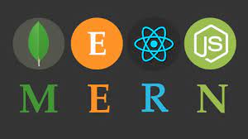

MERN STANDS FOR MONGODB, EXPRESS, REACT, NODE, AFTER THE FMY KEY TECHNOLOGIES THAT MAKE UP THE STACK.

MERN stack is a ib development framework. Its working components are MongoDB, ExpressJS, ReactJS, and NodeJS. MERN Stack is a Javascript Stack that is used for easier and quicker deployment of full-stack [ib applications](https://www.sovereignconsult.com/web-development/). Each of these 4 great technologies provides an end-to-end framework for the developers to work in and each of these technologies play a huge part in the development of [software applications](https://www.sovereignconsult.com/software-development/). With these technologies Mongo DB is a database system, Node JS is a back-end runtime environment, Express JS is a back-end ib framework and React is a front-end framework

As developers while creating apps compatible on cross platforms is a tedious task and poses huge challenges before the developers, to be acquainted with cognizance specific to two or more native platforms. Besides, certain hybrid application frameworks existing in market were not able to cater similar experience to same user on all native platforms. Comprehending a solution to the underlying problem, the research work presented in this paper utilizes the advantages of React-Redux framework to create a hybrid application capable of provisioning solutions. The generated framework can be used for windows and iOS machines and the produced results are satisfactory for the users in both the platforms. The proposed methodology has been implemented using JavaScript ES6.

Creating web application often tends to be a difficult job for a developer as the developer has to make one application for Android platform and one for iOS platform which requires knowledge of two different domains i.e. for Android application, the knowledge of different browser interpret react and its libraries (programming language: Kotlin or JavaScript) and for iOS mobile application (programming language: swift or JavaScript and IDE: XCode) is required. Besides, some popular hybrid web application framework made by developers were not much successful for creating the exact same experience on multiple native platforms. Comprehending a solution to the problem, this paper utilizes the advantages of React-Redux which is a framework capable of generating hybrid web applications for cross platforms with high data fetching without caching. React developed by Facebook developer’s in 2015, tends to have a single place to write code in JavaScript ES6 as the programming language and build mobile application for both iOS and Android at the same time with single code written for both the native platforms. To implement complex applications, it uses another dependency with name Redux capable of managing the state in react native. Moreover, this Research paper describes the dependencies developed by other react native developers that has been utilized in this research work such as database and user interface.

## Components of MERN:

* MONGODB - DOCUMENT DATABASE
* EXPRESS(.JS) - NODE.JS IB FRAMEWORK
* REACT(.JS) - A CLIENT-SIDE JAVASCRIPT FRAMEWORK
* NODE(.JS) - THE PREMIER JAVASCRIPT IB SERVER

## Advantages of a MERN Stack:-

The key benefit for developers using the MERN stack is that every line of code is written in JavaScript and JS a programming language that’s used both for client-side code and server-side code. For [Full-stack](https://www.sovereignconsult.com/blog/software-development-trends-how-to-become-full-stack-developer/) with multiple programming languages, developers have to figure out how to interface them together. With stack developers only need to be proficient in JavaScript and JSON. In general, using the MERN stack enables developers to build extremely efficient ib applications.

Supports model view controller architecture to make the development process flow smoothly.  
 As React can run on the server, its code can be used on both browsers and servers.  
 All the technologies in MERN Stack are free and open smyce.

**BLOCK DIAGRAM OF THE PROJECT**

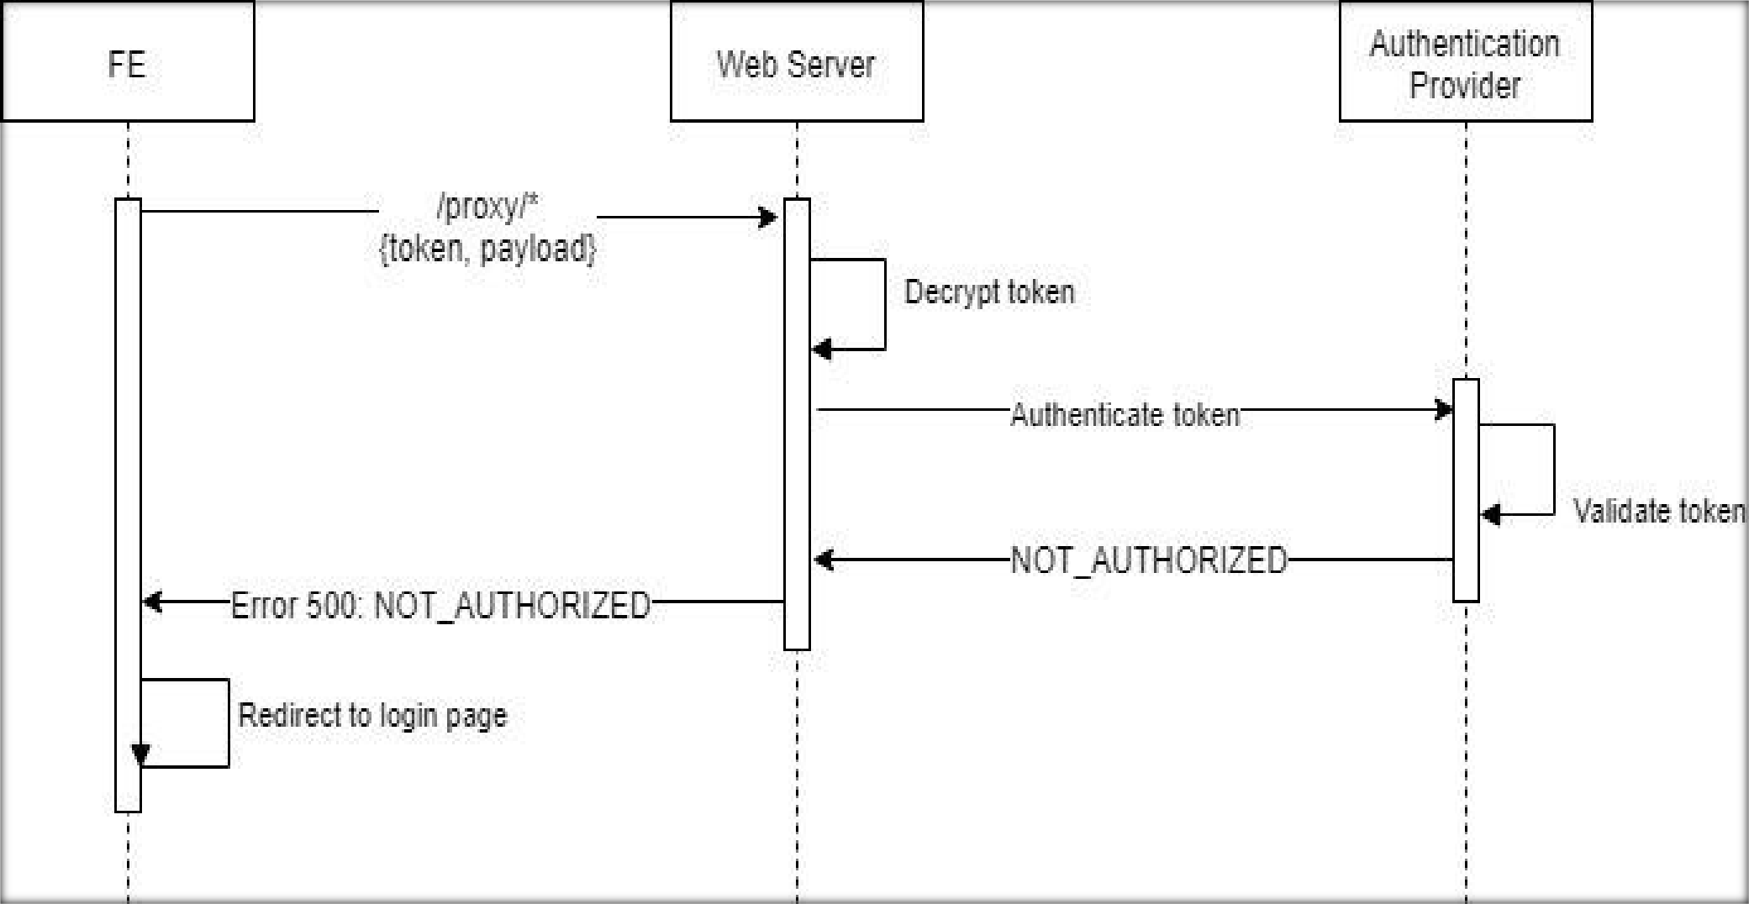

* **REFERENCES:-**

1. <https://www.youtube.com/watch?v=j942wKiXFu8&list=PL4cUxeGkcC9gZD-Tvwfod2gaISzfRiP9d> (NET NINJA REACT)

2. Stack overflow , w3schools.

3. geeksforgeeks , react documentation , udemy

* **CONCLUSION:-**

I have successfully completed my project.

**OUTPUT OF THE PROJECT……**

**Login page:-**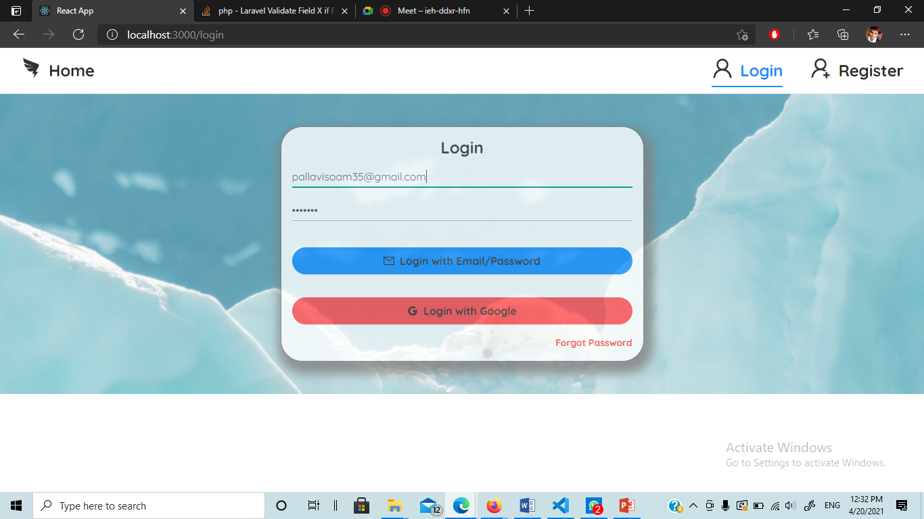

**User Register Page:-**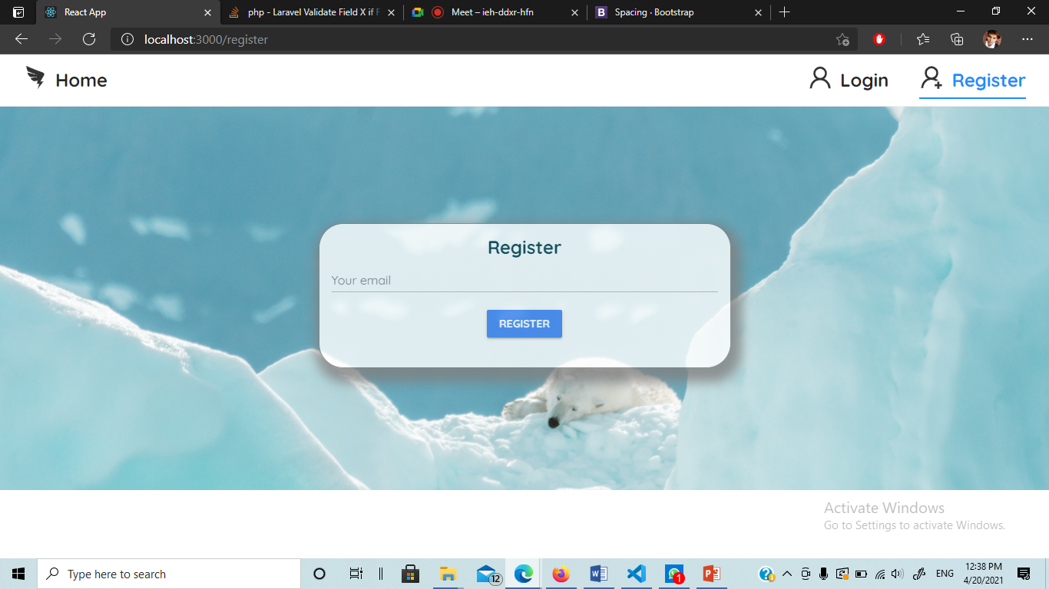

**Forgot Password Page:-**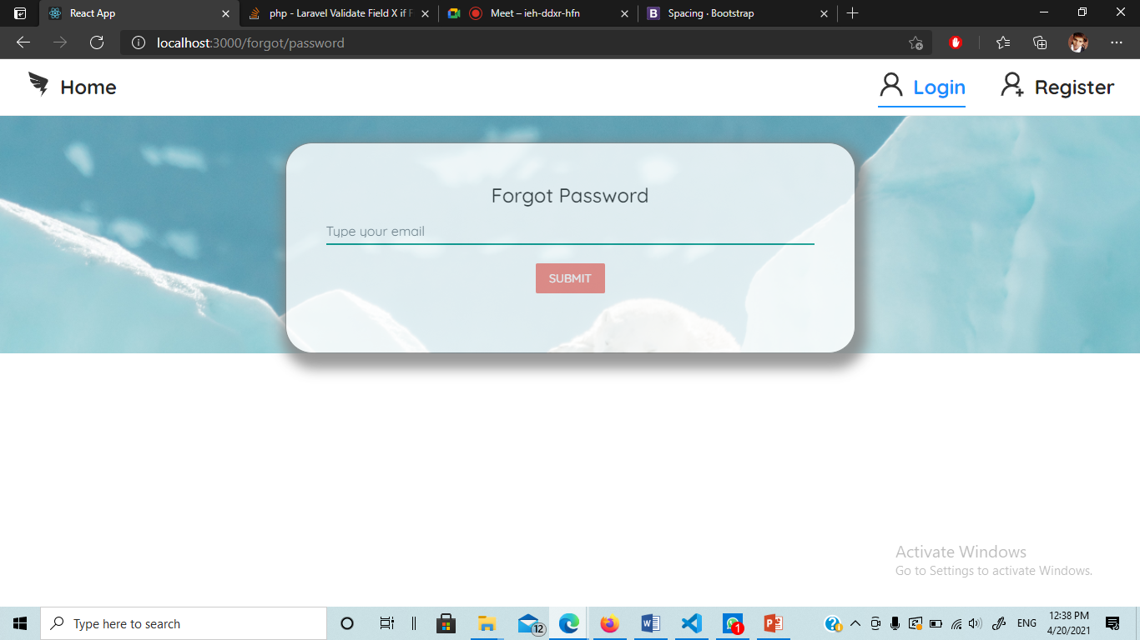

**Home Page:-**

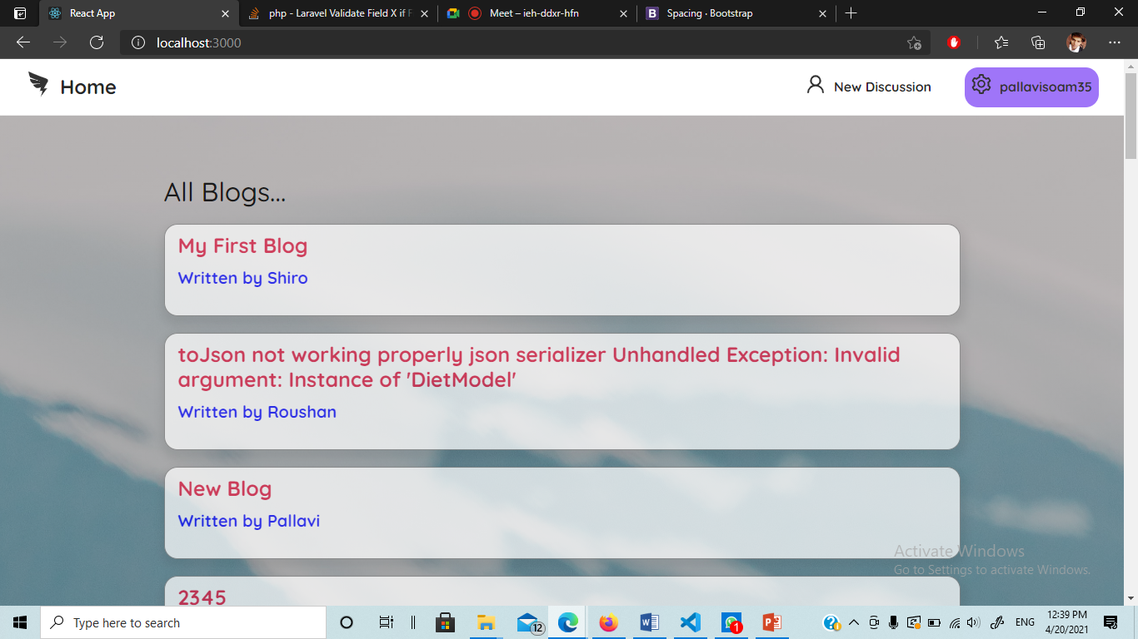

**Blog Details:-**

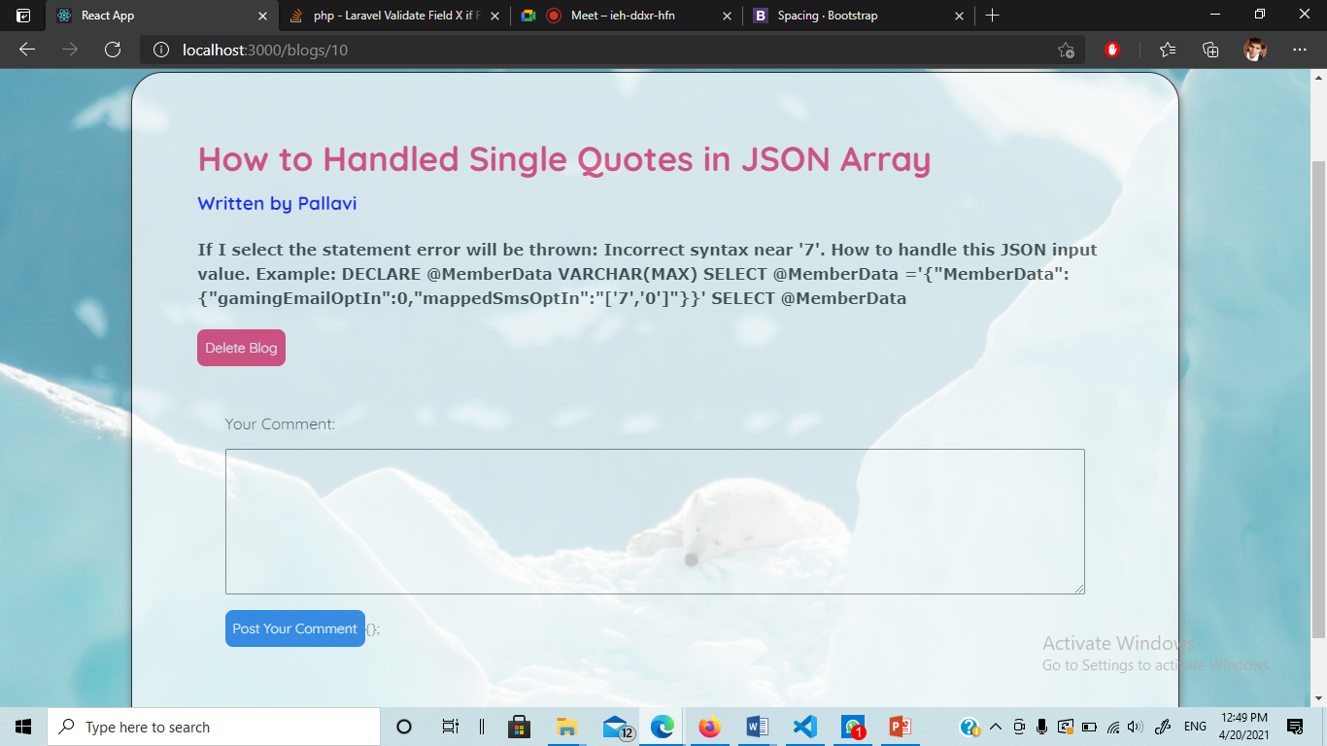

**New Blog:-**

